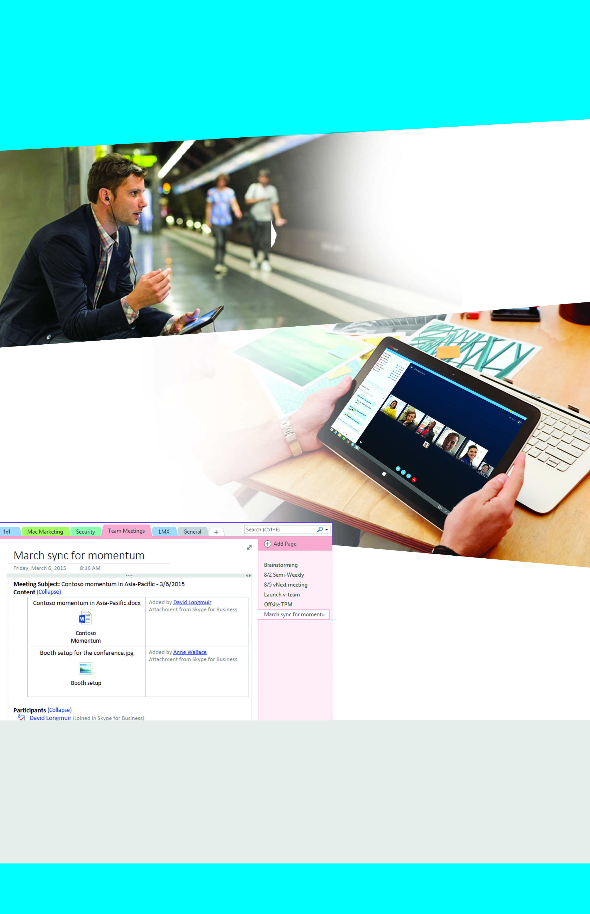

Present and take

notes in real time

Meet from anywhere

With Office 365 and Skype for Business it’s easy to work with team members everywhere using instant messaging, audio and video conferencing, and online meetings.

This poster is designed to post in hallways and public spaces during your Office 365 rollout.

Make sure to customize the areas shown in orange below and print the poster on 11x17 paper.

!

Run more effective meetings

Training

Visit the Office 365 Learning Center at aka.ms/o365learning <If available, add links to your organization’s internal training resources.>

Learn what you can do with Office 365

Community

Events

<Add links to your Office 365 communities or Yammer groups.>

<Tell people about your upcoming Office 365 events. For example, “Join our weekly lunch and learn every Monday at noon in the cafeteria.”>

Feel like you’re

meeting in person